SIMATS
B.E. ELECTRONICS AND COMMUNICATION ENGINEERING
ENGINEERING DESIGN ASSIGNMENT
CO3 – ANALOG AND DIGITAL COMMUNICATION
DIGITAL VOICE AND DATA LINK DESIGN:
FROM SAMPLING AND PULSE TRANSMISSION TO DEPLOYMENT
Submitted by
LOKESH A
Register Number: 192512293
Degree: B.E. Electronics and Communication Engineering (ECE)
Course Code: ECA0801
Course Title: Analog and Digital Communication
Assignment: CO3
Submitted to: Department of Electronics and Communication Engineering

ABSTRACT
This report designs an industrial digital voice/data link using the assignment inputs of 3.4 kHz voice bandwidth, baseline 8 kHz sampling and an 8-bit uniform quantizer. It calculates Nyquist sampling, quantization step/error, SQNR and bit rate; compares PCM, DPCM, DM, ADM and ADPCM; evaluates PAM/PWM/PPM; analyses ISI, Nyquist zero-ISI pulse shaping and eye patterns; designs a TDM multiplexer; selects QPSK with RRC pulse shaping, MMSE equalization/MLSD and synchronization; and maps the architecture to VoIP, DSL and fiber. MATLAB verification code is included. Unspecified channel/hardware data are treated as explicit assumptions, not fabricated measurements.

TABLE OF CONTENTS
- 1. Digital communication design requirements
- 2. Quantization and voice-coding selection
- 3. PAM, PWM and PPM for industrial control
- 4. ISI, Nyquist zero-ISI and eye-pattern analysis
- 5. Digital multiplexing and transmission architecture
- 6. Digital modulation, MLSD, equalization and synchronization
- 7. VoIP, DSL and fiber-optic validation
- 8. MATLAB verification and final engineering decision
- References
- Appendix A – MATLAB script

1. DIGITAL COMMUNICATION DESIGN REQUIREMENTS

1.1 Engineering problem and design assumptions
A smart industrial network must acquire voice, control and monitoring information, digitize and encode it, combine multiple sources, transmit through a bandwidth-limited noisy channel, and reconstruct the information. The question paper leaves the final coding, modulation, multiplexing, equalization and synchronization methods open; this report selects them using explicit calculations.
Parameter | Given requirement | Design interpretation
Voice bandwidth | 3.4 kHz | Maximum message frequency = 3.4 kHz.
Sampling | Baseline 8 kHz | Use 8 kHz; anti-alias filter passband to 3.4 kHz.
Quantizer | 8-bit uniform | 256 levels; assume normalized range −1 V to +1 V.
Channel | AWGN and ISI | Use AWGN and illustrative dispersive channel; real channel must be measured.
Applications | Industrial voice/control, VoIP, DSL, fiber | Common source/framing concepts; application-specific PHY.
Pulse techniques | PAM, PWM, PPM | Compare all; PWM chosen for local actuator command.
Coding | PCM, DPCM, DM, ADM, ADPCM | ADPCM chosen as compressed voice option; PCM baseline.
Receiver | Equalization and synchronization | Matched filtering, timing/carrier recovery and equalization.

1.2 End-to-end communication system
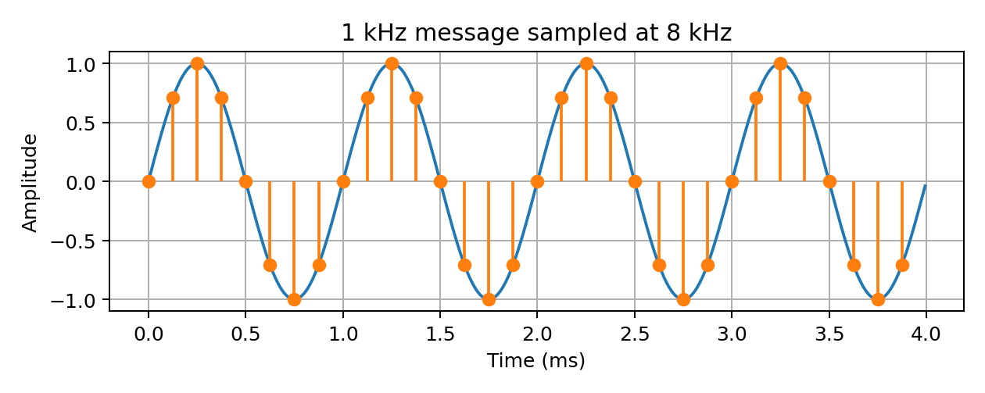
Figure 1. Sampling illustration at 8 kHz for a 1 kHz tone.
End-to-end chain: source → anti-alias filter → sampler/ADC → quantizer and voice coder → framing/TDM multiplexer → optional channel coding → digital modulator/pulse shaper → channel → matched filter → timing/carrier recovery → equalizer/demodulator/decoder → de-multiplexer → voice decoder/DAC/reconstruction filter → destination.

1.3 Nyquist sampling and 8 kHz suitability
For a band-limited signal, the ideal Nyquist criterion requires f_s ≥ 2f_max. Here f_max = 3.4 kHz, therefore f_s,min = 2(3.4) = 6.8 kHz. The specified 8 kHz baseline exceeds this by 1.2 kHz. Its Nyquist frequency is 4 kHz, leaving a 600 Hz transition interval above the 3.4 kHz audio passband.
An analog anti-alias low-pass filter must suppress components above 4 kHz before sampling. Undersampling causes spectral replicas to overlap; the resulting alias cannot be removed digitally after sampling. For example, a 4.5 kHz tone sampled at 8 kHz appears at |4.5−8| = 3.5 kHz.

1.4 Initial information rate
For 8 kHz sampling and 8 bits/sample, R_PCM = 8,000 × 8 = 64,000 bit/s = 64 kb/s per voice channel. This is the raw payload before framing, headers or error-control coding. A 4-bit/sample ADPCM option gives 8,000 × 4 = 32 kb/s.

1.5 Channel and application constraints
- Bandwidth: pulse shaping and modulation set occupied spectrum; framing/FEC increase line rate.
- Noise: AWGN, impulse noise, crosstalk, optical receiver noise and interference produce errors.
- ISI: multipath, cable dispersion and filtering spread pulses across symbol intervals.
- Timing: sampling-clock jitter, symbol timing error and frame slips corrupt decisions.
- Implementation: ADC/DAC resolution, DSP complexity, latency, power, synchronization and cost.
Application | Dominant requirements
VoIP | Packet delay/jitter, codec rate, packet loss, timestamps, jitter buffer, QoS and congestion.
DSL | Copper-loop attenuation, crosstalk, frequency selectivity, adaptive equalization and synchronization.
Fiber | High aggregate rate, optical/electrical conversion, chromatic dispersion, receiver sensitivity and clock/data recovery.

1.6 Digital Communication Design Requirement Statement
Design a voice/data link for 3.4 kHz voice using 8 kHz sampling, anti-alias filtering and 8-bit uniform quantization as the baseline. The baseline PCM rate is 64 kb/s per channel; a 4-bit ADPCM option is 32 kb/s. The channel is bandwidth-limited and affected by AWGN and ISI. The system must support industrial control, VoIP, DSL and fiber adaptations, synchronization, equalization, acceptable reconstructed voice quality and scalable multiplexing.

Stage decision
Retain 8 kHz sampling because it exceeds the 6.8 kHz Nyquist minimum. The anti-alias filter must preserve 3.4 kHz audio while attenuating energy above the 4 kHz Nyquist frequency.

2. QUANTIZATION AND VOICE-CODING SELECTION

2.1 Uniform quantizer calculation
Assume a normalized full-scale input range of −1 V to +1 V. For N = 8 bits, the number of levels is L = 2^8 = 256. The step size is Δ = (1−(−1))/256 = 0.0078125 V = 7.8125 mV. The ideal maximum quantization error magnitude is Δ/2 = 3.90625 mV, provided the input does not overload the quantizer.
Figure 2. Sampling remains above the Nyquist minimum; quantization is performed after sampling.

2.2 SQNR
For an ideal uniform quantizer and a full-scale sinusoid, SQNR_dB ≈ 6.02N + 1.76 = 6.02(8)+1.76 = 49.92 dB. This is a theoretical reference. Real voice has a lower average level than a full-scale sine, so its measured average SQNR may be lower; overload, analog noise and nonlinearity also reduce performance.

2.3 Voice-coding comparison
Method | Rate characteristic at 8 kHz | Noise / quality | Complexity and use
PCM | 8 bits/sample = 64 kb/s | Direct quantization; predictable baseline quality. | Simple and robust; highest rate here.
DPCM | Predictor error encoded; rate depends on quantizer bits. | Lower rate when prediction is accurate; predictor errors matter. | Predictor and quantizer required.
DM | 1 bit/sample = 8 kb/s | Granular noise at low slope; slope overload at fast changes. | Simple; often needs oversampling.
ADM | Typically 1 bit/sample | Adaptive step reduces fixed-step DM compromise. | More control logic than DM.
ADPCM | 4 bits/sample = 32 kb/s proposal | Adaptive prediction/quantization provides useful voice quality at lower rate. | Moderate DSP; practical voice compression.

2.4 Selected coding method and trade-off
Select 4-bit/sample ADPCM as the bandwidth-efficient voice payload: 8,000 × 4 = 32 kb/s, half the 64 kb/s 8-bit PCM baseline. PCM remains a fallback where simplicity or a transparent reference is preferred. DM/ADM are attractive for simple low-rate control/voice experiments but can require oversampling and careful step adaptation. The exact ADPCM profile must be chosen for interoperability; no codec conformance test is claimed.
Metric | 8-bit PCM | 4-bit ADPCM
Sampling | 8 kHz | 8 kHz
Bits/sample | 8 | 4
Payload rate | 64 kb/s | 32 kb/s
Relative rate | 100% | 50%
Processing | Direct quantization | Adaptive prediction and quantization

Stage decision
Use 4-bit ADPCM at 8 kHz (32 kb/s/channel) for compressed voice, with 8-bit PCM as baseline. The 49.92 dB SQNR is the ideal full-scale sine benchmark for the uniform quantizer, not a guaranteed voice-quality measurement.

3. PAM, PWM AND PPM FOR INDUSTRIAL CONTROL

3.1 Common information signal
Let m(t) = 0.5 + 0.4 sin(2πf_mt), bounded between 0.1 and 0.9. PAM varies pulse amplitude; PWM varies pulse width/duty cycle; PPM varies pulse position relative to a frame reference.
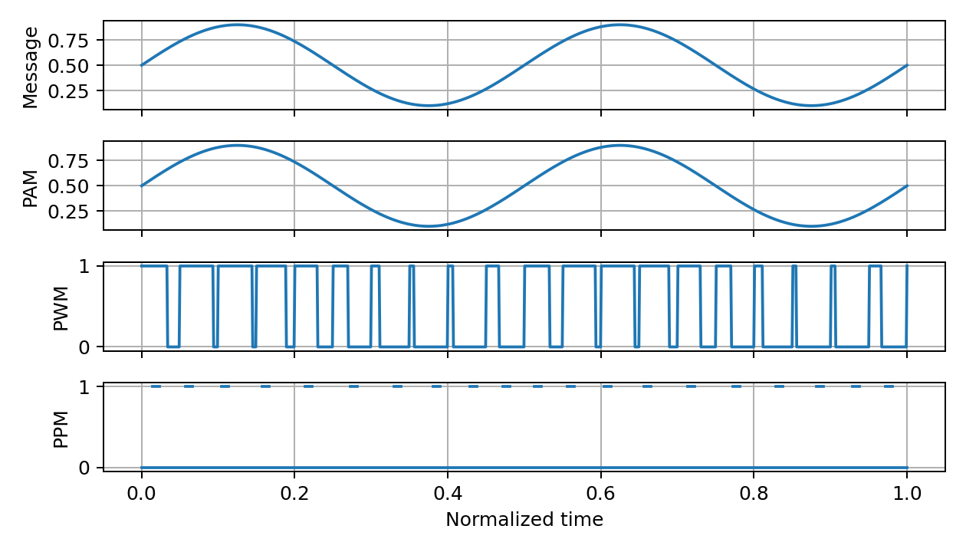
Figure 3. PAM, PWM and PPM waveform comparison using a common information signal.

3.2 Comparative analysis
Parameter | PAM | PWM | PPM
Information variable | Pulse amplitude | Pulse width / duty | Pulse time position
Amplitude-noise sensitivity | High | Lower if threshold crossings remain valid | Lower if pulse detection remains reliable
Timing/jitter sensitivity | Sampling instant matters | Edge timing affects duty measurement | High; timing carries information
Bandwidth | Pulse-shape dependent | Sharp edges produce harmonics | Short pulses and timing precision can require bandwidth
Power | Amplitude varies | Fixed amplitude; average power follows duty | Fixed pulse amplitude/width; energy can be nearly constant
Synchronization | Sample/frame timing | Frame timing and duty measurement | Precise frame reference
Complexity | Low | Low–moderate | Higher timing precision

3.3 PWM selection for motor/actuator control
Select PWM for a local motor or actuator command. For an ideal unipolar switching stage, average applied voltage is approximately V_avg = D V_supply. At D = 0.60 and V_supply = 24 V, V_avg ≈ 14.4 V. Fixed-amplitude pulses make the command less sensitive to amplitude variation than PAM, and timer hardware generates PWM efficiently. This approximation ignores switching losses, motor inductance and driver drops.
PWM is not immune to all impairments: threshold noise, edge jitter and pulse distortion change the measured duty cycle. Use a Schmitt-trigger input, suitable grounding, differential signalling where needed, filtering and fail-safe duty limits.

3.4 RCC Standard 106-20 Annex A-1
RCC Standard 106-20 Annex A-1 is titled “Pulse Amplitude Modulation Standards” (July 2020). It is a PAM telemetry reference: it describes time-division-multiplexed analog pulse channels, frame synchronization and calibration intervals. It specifies up to 128 channel time intervals per frame including synchronization/calibration intervals, illustrates a 50% duty-cycle PAM structure, and recommends reserving 20–25% deviation for pulse synchronization. It is not a general standard for the PWM actuator interface.
Control and voice/data objectives differ. A control link may prioritize deterministic duty-cycle response and simple hardware; voice/data transport prioritizes source fidelity, coding, packet timing, spectral efficiency and error control. PWM is suitable for a local motor command but does not replace a digital voice codec or broadband line modulation.

Stage decision
Select PWM for the actuator/motor control interface because duty cycle maps directly to average applied voltage and can be generated with simple timer hardware. PPM is more timing-sensitive; PAM is more directly affected by amplitude variation.

4. ISI, NYQUIST ZERO-ISI AND EYE-PATTERN ANALYSIS

4.1 ISI and Nyquist criterion
Inter-symbol interference occurs when channel or pulse-shaping responses spread one symbol into neighbouring symbol intervals. The received decision sample then contains contributions from adjacent symbols. Causes include limited bandwidth, multipath, cable reflections, filter mismatch and dispersion.
The first Nyquist zero-ISI condition for the overall pulse response p(t), sampled every symbol period T, is p(0)=1 and p(kT)=0 for every non-zero integer k. At the correct sampling instant, all other symbols therefore contribute zero interference.

4.2 Raised-cosine pulse shaping
A raised-cosine spectrum satisfies the zero-ISI criterion. Select root-raised-cosine (RRC) transmit and receive filters with roll-off α = 0.25. Their cascade is a raised-cosine response in the ideal synchronized channel. The approximate passband null-to-null bandwidth is B ≈ R_s(1+α), where R_s=1/T is symbol rate.

4.3 Illustrative channel and eye pattern
For analysis, use a discrete illustrative channel h[n]=[1, 0.35, 0.15]. The sampled output is r[k]=a[k]+0.35a[k−1]+0.15a[k−2]+w[k]. Neighbouring-symbol terms create ISI. This assumed model is not a measured plant, DSL or fiber channel.
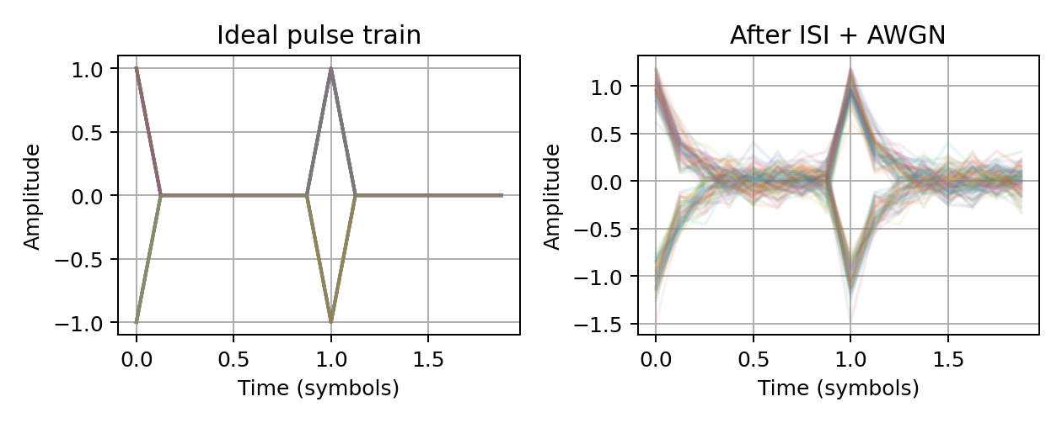
Figure 4. Illustrative eye-pattern comparison before and after an ISI + AWGN channel.
Eye measure | Meaning | Engineering interpretation
Eye height | Vertical opening at optimum sample time | Noise margin; larger opening tolerates more amplitude noise.
Eye width | Horizontal opening around sample time | Timing margin; wider opening tolerates more jitter.
Timing margin | Allowed sample-time error | Sample near eye centre after timing recovery.
Noise margin | Distance from decision threshold | Larger margin reduces noise-induced decisions.
Eye closure | Reduced opening due to noise/ISI/jitter | Increases symbol-error probability.

4.4 Pulse-shaping/equalization alternatives
Approach | Advantage | Limitation
RC/RRC matched filtering | Controls bandwidth; matched filter improves AWGN SNR; ideal cascade gives zero ISI at sampling instants. | Timing alignment and channel matching required.
Zero-forcing equalizer | Attempts to invert channel response and cancel ISI. | Can amplify noise near spectral nulls.
MMSE equalizer | Balances residual ISI and noise enhancement. | Needs channel/noise estimates and adaptation.

Choose RRC pulse shaping plus an adaptive MMSE equalizer. ML sequence detection can further improve sequence recovery when channel memory is short and processing resources permit. DSL often uses frequency-domain equalization and bit loading; fiber may need dispersion compensation and clock recovery.
Eye height reduction makes noise more likely to cross a decision threshold. Eye width reduction makes timing jitter more likely to move the sample away from the optimum instant. Both increase symbol-error probability; a plot alone does not establish a numerical BER without a defined signal/channel/noise model.

Stage decision
Use RRC pulse shaping with α=0.25, matched filtering and adaptive MMSE equalization. This provides bandwidth control and a practical noise/ISI compromise; sample at the widest eye opening.

5. DIGITAL MULTIPLEXING AND TRANSMISSION ARCHITECTURE

5.1 TDM frame and aggregate rate
Design a synchronous TDM frame for 16 voice channels, each using 4-bit ADPCM at 8 kHz. Frame period = 1/8,000 = 125 μs. Each channel contributes 4 bits per frame, giving 16×4=64 payload bits. Add an 8-bit frame-sync word.
R_payload = 16 × 4 × 8,000 = 512,000 bit/s = 512 kb/s. R_framed = (64+8) bits/frame × 8,000 frames/s = 576 kb/s. Sync overhead is 64 kb/s; payload efficiency = 64/72 = 88.89%. Further FEC/control overhead increases the line rate.
Frame field | Bits/frame | Purpose
Frame synchronization | 8 | Detect frame boundary and align slots.
Voice slot 1 | 4 | ADPCM sample for channel 1.
Voice slots 2–16 | 60 | ADPCM samples for remaining channels.
Total | 72 | One frame each 125 μs; 576 kb/s.

Slot order repeats as [SYNC | CH1 | CH2 | … | CH16]. The receiver detects the sync word, aligns frame timing and routes each 4-bit slot to the correct ADPCM decoder.

5.2 TDM versus FDM
Criterion | TDM | FDM
Allocation | Different time slots on shared channel. | Separate frequency sub-bands.
Synchronization | Frame and slot timing required. | Frequency stability and filtering required.
Guarding | May use guard time. | Frequency guard bands reduce adjacent-channel interference.
Scalability | Add slots within aggregate capacity. | Add sub-bands within total spectrum.
Complexity | Framing, buffering, clock sync. | Channel filters, oscillators, frequency planning.

5.3 Application-specific multiplexing
- VoIP: packet/statistical multiplexing at IP layer; timestamps, sequence numbers, jitter buffers and QoS manage variable packet arrivals.
- DSL: DMT multicarrier access with per-tone bit loading and framing; it is not simply a fixed 16-slot voice TDM.
- Fiber: high-rate TDM or packet aggregation; WDM provides multiple optical wavelength channels.

Stage decision
Use synchronous TDM for the specified 16-channel industrial voice example because it provides deterministic 125 μs frames and a calculable 576 kb/s framed rate. Packet aggregation suits VoIP; WDM/packet transport suits fiber backbones.

6. DIGITAL MODULATION, MLSD, EQUALIZATION AND SYNCHRONIZATION

6.1 Modulation comparison and selection
Scheme | Bits/symbol | Bandwidth/power trade-off | Complexity
BPSK | 1 | Robust, lower spectral efficiency, good power efficiency. | Low; coherent carrier recovery.
QPSK | 2 | Good spectral efficiency and power efficiency; noise tolerance better than higher-order QAM at same Eb/N0. | Moderate; carrier/timing recovery.
16-QAM | 4 | Higher spectral efficiency but closer constellation points and higher SNR/linearity needs. | Higher.

Select QPSK for the aggregate industrial link. For R_b=576 kb/s, R_s=R_b/log₂4=288 ksymbol/s. With RRC α=0.25, approximate null-to-null bandwidth B≈R_s(1+α)=288×1.25=360 kHz. This is a theoretical estimate before additional FEC/control overhead.

6.2 MLSD and equalization
Maximum Likelihood Sequence Detection (MLSD) chooses the transmitted symbol sequence that maximizes likelihood given the received samples and channel model. A finite-memory channel is represented by a trellis; branch metrics compare received samples with predicted channel outputs, and the Viterbi algorithm selects the best path. MLSD can outperform symbol-by-symbol detection but complexity grows with channel memory and constellation size.
Method | Operation | Trade-off
ZF | Invert channel response to cancel ISI. | May amplify noise near channel nulls.
MMSE | Minimize mean-square error considering ISI and noise. | Good compromise; needs estimates/adaptation.
DFE | Use previous decisions to cancel post-cursor ISI. | Moderate complexity; error propagation possible.
MLSD/Viterbi | Joint sequence detection over finite-memory channel. | Strong performance; potentially high complexity.

Use adaptive MMSE as the default equalizer; use MLSD for short-memory channels when processing permits. DFE is an alternative for longer channels where MLSD is too complex.

6.3 Timing, carrier and frame synchronization
- Timing recovery: Gardner or Mueller–Müller timing-error detector drives a loop to sample near the eye centre.
- Carrier recovery: Costas loop or decision-directed PLL estimates coherent QPSK carrier phase/frequency.
- Frame synchronization: detects TDM sync word and restores slot alignment; a frame slip can misroute all subsequent data.
Timing error increases ISI and symbol errors. Carrier phase error rotates the QPSK constellation; frequency offset causes continuous phase rotation. Frame timing error corrupts channel-slot assignment.

Stage decision
Select QPSK with α=0.25 RRC pulse shaping, adaptive MMSE equalization (MLSD for short-memory channels), timing recovery, Costas-loop carrier recovery and explicit TDM frame synchronization.

7. VoIP, DSL AND FIBER-OPTIC APPLICATION VALIDATION
Feature | VoIP | DSL access | Fiber backbone
Coding | Codec chosen for quality/rate and interoperability. | Service voice may be packetized; data access dominates. | Voice/data aggregated into high-rate frames/packets.
Multiplexing | Packet/statistical multiplexing, RTP/UDP/IP. | DMT multicarrier and resource allocation. | TDM/packet switching and WDM.
Impairment | Packet loss, jitter, delay, congestion. | Copper attenuation, crosstalk, frequency selectivity, ISI. | Chromatic dispersion, polarization effects, optical noise.
Recovery | Timestamps, jitter buffers, access-PHY clock recovery. | Adaptive equalization, bit loading, echo/crosstalk cancellation. | Dispersion compensation and clock/data recovery.
Unsuitable transfer | Fixed TDM is not the usual IP service model. | PWM is not a broadband DSL line code. | Generic PWM/PPM control pulses are not backbone transport.

7.1 Application recommendations
VoIP: use an interoperable codec, RTP timestamps/sequence numbers, jitter buffering, QoS and packet-loss concealment. The 32 kb/s ADPCM rate is a design option, not a universal VoIP mandate.
DSL: use a DSL-specific multicarrier PHY with adaptive bit loading, channel estimation, equalization and echo/crosstalk management. The QPSK link in this report is a conceptual tributary design, not a replacement for a standardized DSL modem.
Fiber: use optical transceivers, framing/FEC, WDM or packet/TDM aggregation, clock/data recovery and dispersion management. The 576 kb/s example is an access tributary, not a backbone capacity target.
The source-coding and framing concepts can be shared, but physical-layer methods differ: VoIP is packet-centric, DSL is a frequency-selective copper access system, and fiber is a high-capacity optical medium.

8. MATLAB VERIFICATION AND FINAL ENGINEERING DECISION

8.1 Verification plan and theoretical checks
Test | Expected result | Interpretation
Nyquist | Minimum 6.8 kHz; chosen 8 kHz. | 600 Hz transition above 3.4 kHz audio edge.
PCM rate | 64 kb/s/channel. | 8,000 samples/s × 8 bits.
Quantizer | 256 levels; Δ=7.8125 mV for ±1 V range. | Max ideal error 3.90625 mV.
SQNR | 49.92 dB full-scale sine. | Ideal theoretical benchmark.
ADPCM | 32 kb/s/channel at 4 bits/sample. | Half of PCM payload rate.
TDM | 576 kb/s for 16 ADPCM channels + sync. | 72 bits × 8,000 frames/s.
QPSK | 288 ksymbol/s; about 360 kHz at α=.25. | R_s(1+α) estimate.

Appendix A provides a MATLAB script for sampling/aliasing, uniform quantization/SQNR, PCM/DPCM/DM/ADM-style reconstruction, PAM/PWM/PPM, an ISI channel, eye diagrams, QPSK/AWGN, phase-offset effects and rate calculations. The report's figures are explanatory illustrations and are not claimed as MATLAB execution outputs. Run the script and retain the generated figures/console output as actual simulation evidence.

8.2 Critical evaluation
Simulation depends on channel impulse response, SNR, filter span, samples/symbol, timing offset and carrier phase/frequency error. The channel taps used here are assumptions, not measured plant/DSL/fiber data. No hardware BER, measured eye opening, codec MOS or field performance is claimed.

8.3 Final engineering decision
DEPLOYMENT DECISION: CONDITIONAL YES for a controlled prototype and lab/field trial; NO-GO for full production until channel characterization, interoperability, latency, BER, eye opening, synchronization and application-specific compliance are verified. The design is coherent for an industrial voice/control tributary, but VoIP, DSL and fiber require their own standardized access and physical layers.

8.4 Specification-verification table
Requirement | Specified | Proposed result | Status
Voice bandwidth | 3.4 kHz | 3.4 kHz passband | YES
Sampling | 8 kHz baseline | 8 kHz; minimum 6.8 kHz | YES
Quantization | 8-bit uniform | 256 levels; 7.8125 mV step | YES
SQNR | Calculate | 49.92 dB ideal sine | Theoretical
Voice coding | PCM/DPCM/DM/ADM/ADPCM | 4-bit ADPCM proposal; PCM baseline | Profile to select
Pulse techniques | PAM/PWM/PPM | Compared; PWM selected for actuator | YES
ISI/zero-ISI | Required | RRC α=.25 + MMSE; illustrative channel | Test needed
Eye diagrams | Required | Analysis + MATLAB script | Run MATLAB
Multiplexing | Digital mux, TDM/FDM | 16-channel TDM, 576 kb/s | YES
Digital modulation | Select | QPSK, 288 ksym/s, ~360 kHz | Proposed
Equalization/MLSD | Required | MMSE; MLSD if short memory | Proposed
Synchronization | Required | Timing, Costas carrier, frame sync | Proposed
VoIP/DSL/fiber | All | Application mapping included | Conceptual
MATLAB verification | Required | Runnable script included, not executed | Pending
Deployment | YES/NO | Prototype conditional YES; production NO-GO | Conditional

8.5 Conclusion
The design retains 8 kHz sampling for 3.4 kHz voice, calculates 256-level 8-bit quantization and 49.92 dB ideal full-scale sine SQNR, and proposes 4-bit ADPCM at 32 kb/s. PWM is selected for local actuator control; 16-channel TDM produces a 576 kb/s framed stream. QPSK with RRC α=.25 gives a 288 ksymbol/s symbol rate and approximately 360 kHz theoretical bandwidth. RRC matched filtering, MMSE equalization, timing/carrier recovery and optional MLSD address ISI and synchronization. VoIP, DSL and fiber reuse coding/framing concepts but require distinct packet, copper-access and optical physical layers. Proceed to prototype only after MATLAB execution, channel characterization and BER/eye/interoperability tests.

REFERENCES
- [1] Range Commanders Council, RCC Standard 106-20, Telemetry Standards, Annex A-1: Pulse Amplitude Modulation Standards, July 2020. https://www.irig106.org/docs/106-20/annexa-1.pdf
- [2] MathWorks, “Filtering in Communication Systems,” MATLAB & Simulink Documentation. https://www.mathworks.com/help/comm/ug/filtering.html
- [3] MathWorks, “Scatter Plot and Eye Diagram with MATLAB Functions,” Communications Toolbox Documentation. https://www.mathworks.com/help/comm/gs/scatter-plot-and-eye-diagram-with-matlab-functions.html
- [4] MathWorks, “pskmod – Modulate signal using M-PSK method.” https://www.mathworks.com/help/comm/ref/pskmod.html
- [5] J. G. Proakis and M. Salehi, Digital Communications, 5th ed., McGraw-Hill, 2008.
- [6] B. P. Lathi and Z. Ding, Modern Digital and Analog Communication Systems, 4th ed., Oxford University Press, 2009.
- [7] A. Gersho and R. M. Gray, Vector Quantization and Signal Compression, Kluwer Academic Publishers, 1992.
Reference note: RCC 106-20 Annex A-1 is a PAM telemetry standard and is applied only within that scope. MATLAB documentation supports the raised-cosine, eye-diagram and modulation implementation examples. Unspecified codec profiles and channel parameters remain design assumptions.

APPENDIX A – MATLAB VERIFICATION SCRIPT
The following script is a compact reproducible starting point. It uses base MATLAB for core signal generation and requires Communications Toolbox for optional pskmod/pskdemod, eyediagram and rcosdesign functions. The illustrative channel is not a measured industrial channel.
%% CO3 digital voice/data link - MATLAB
clear; close all; clc; rng(7);
%% Sampling and aliasing
fm=3400; Fs=8000; T=.02; t=(0:1/200000:T).';
x=sin(2*pi*1000*t)+.25*sin(2*pi*fm*t);
ts=(0:1/Fs:T).'; xs=sin(2*pi*1000*ts)+.25*sin(2*pi*fm*ts);
figure; plot(t,x); hold on; stem(ts,xs,'filled'); grid on;
title('Sampling at 8 kHz'); xlabel('Time (s)');
fprintf('Nyquist minimum = %.1f kHz\n',2*fm/1e3);
%% Uniform quantizer and SQNR
N=8; L=2^N; xmin=-1; xmax=1; Delta=(xmax-xmin)/L;
v=.95*sin(2*pi*1000*t); idx=floor((v-xmin)/Delta);
idx=min(max(idx,0),L-1); vq=xmin+(idx+.5)*Delta; err=v-vq;
sqnrSim=10*log10(mean(v.^2)/mean(err.^2)); sqnrTh=6.02*N+1.76;
fprintf('Levels=%d Delta=%.8f V max error=%.8f V\n',L,Delta,Delta/2);
fprintf('Theoretical SQNR=%.2f dB simulated=%.2f dB\n',sqnrTh,sqnrSim);
figure; plot(t(1:1000),v(1:1000)); hold on; stairs(t(1:1000),vq(1:1000));
grid on; legend('Input','Quantized');
%% DPCM, DM and adaptive DM illustration
pred=[0;vq(1:end-1)]; dpcmError=vq-pred;
mu=.02; dm=zeros(size(v)); adm=zeros(size(v)); step=.01; last=-1; run=0;
for n=2:length(v)
if v(n)>=dm(n-1), b=1; dm(n)=dm(n-1)+mu;
else, b=0; dm(n)=dm(n-1)-mu; end
if b==last, run=run+1; else, run=0; end
if run>=2, step=min(step*1.5,.08); else, step=max(step*.9,.002); end
if v(n)>=adm(n-1), adm(n)=adm(n-1)+step; last=1;
else, adm(n)=adm(n-1)-step; last=0; end
end
figure; plot(t(1:1500),v(1:1500),'k',t(1:1500),dm(1:1500),'r',t(1:1500),adm(1:1500),'b');
grid on; legend('Input','DM','ADM');
%% PAM/PWM/PPM common message
Fp=1000; Fsp=100000; tp=(0:1/Fsp:.02).'; msg=.5+.4*sin(2*pi*50*tp);
phase=mod(tp*Fp,1); pam=msg; pwm=double(phase<msg);
ppm=double(phase>=(1-msg)*.75 & phase<(1-msg)*.75+.08);
figure; subplot(3,1,1);plot(tp,pam);title('PAM');grid on;
subplot(3,1,2);plot(tp,pwm);title('PWM');grid on;
subplot(3,1,3);plot(tp,ppm);title('PPM');grid on;
%% ISI channel and eye diagram
Ns=2000; sps=8; symbols=2*randi([0 1],Ns,1)-1;
u=zeros(Ns*sps,1);u(1:sps:end)=symbols;
h=[1 .35 .15]; rx=filter(h,1,u)+.12*randn(size(u));
figure;plot(rx(1:1000));title('ISI channel + AWGN');grid on;
if exist('eyediagram','file'), figure;eyediagram(rx(1:4000),2*sps);end
%% QPSK/AWGN/phase offset (Communications Toolbox)
M=4; Nsym=5000; data=randi([0 M-1],Nsym,1);
if exist('pskmod','file')
tx=pskmod(data,M,pi/4); snrDb=12;
noise=(randn(size(tx))+1i*randn(size(tx)))*sqrt(mean(abs(tx).^2)/(2*10^(snrDb/10)));
r=tx+noise; rPhase=r*exp(1i*20*pi/180);
out=pskdemod(r,M,pi/4); outPhase=pskdemod(rPhase,M,pi/4);
fprintf('SER=%g; SER with 20 degree phase error=%g\n',mean(out~=data),mean(outPhase~=data));
figure;plot(real(r),imag(r),'.');axis equal;grid on;title('QPSK constellation');
end
%% RRC pulse shaping (Communications Toolbox)
if exist('rcosdesign','file')
alpha=.25; span=10; spsQ=4; rrc=rcosdesign(alpha,span,spsQ,'sqrt');
txFilt=upfirdn(tx,rrc,spsQ,1);
rxNoisy=txFilt+.05*(randn(size(txFilt))+1i*randn(size(txFilt)));
rxFilt=filter(rrc,1,rxNoisy);
if exist('eyediagram','file'), figure;eyediagram(real(rxFilt(1:2000)),2*spsQ);end
end
%% Rate calculations
fsVoice=8000; Rpcm=fsVoice*8; Radpcm=fsVoice*4; nVoice=16;
Rframed=(nVoice*4+8)*fsVoice; Rs=Rframed/log2(M); BW=Rs*(1+.25);
fprintf('PCM=%g kb/s ADPCM=%g kb/s per channel\n',Rpcm/1e3,Radpcm/1e3);
fprintf('TDM framed rate=%g kb/s; QPSK Rs=%g ksym/s; BW~%g kHz\n',Rframed/1e3,Rs/1e3,BW/1e3);

